Secure Coding Lab – 9

Dasari Mohan Amritesh

18BCN7038

**Install Frigate3 on Windows 7 VM:**

Frigate3 UI

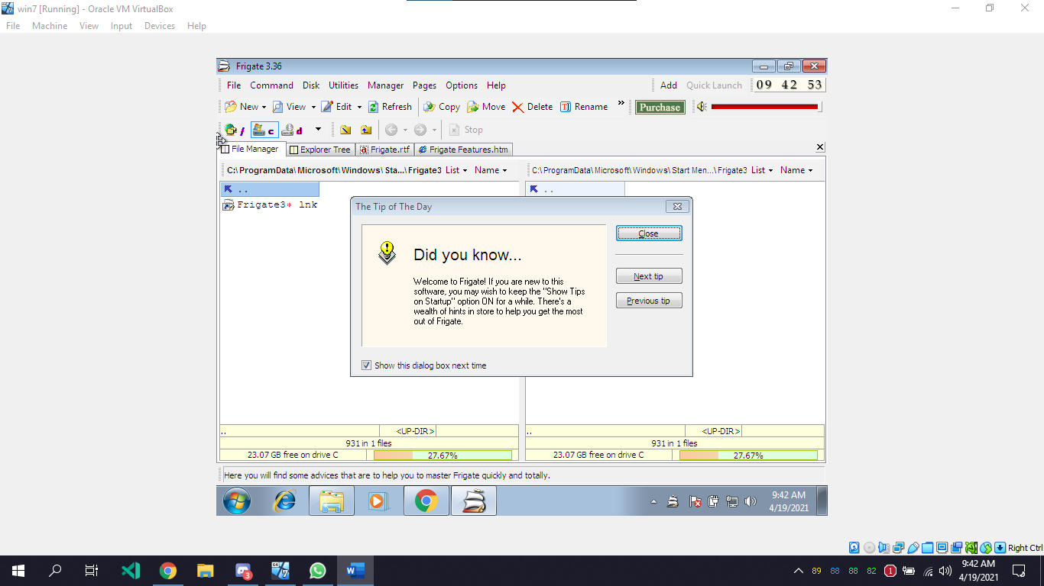

**Execute the exploit2.py to generate the payload_cmd.txt file:**

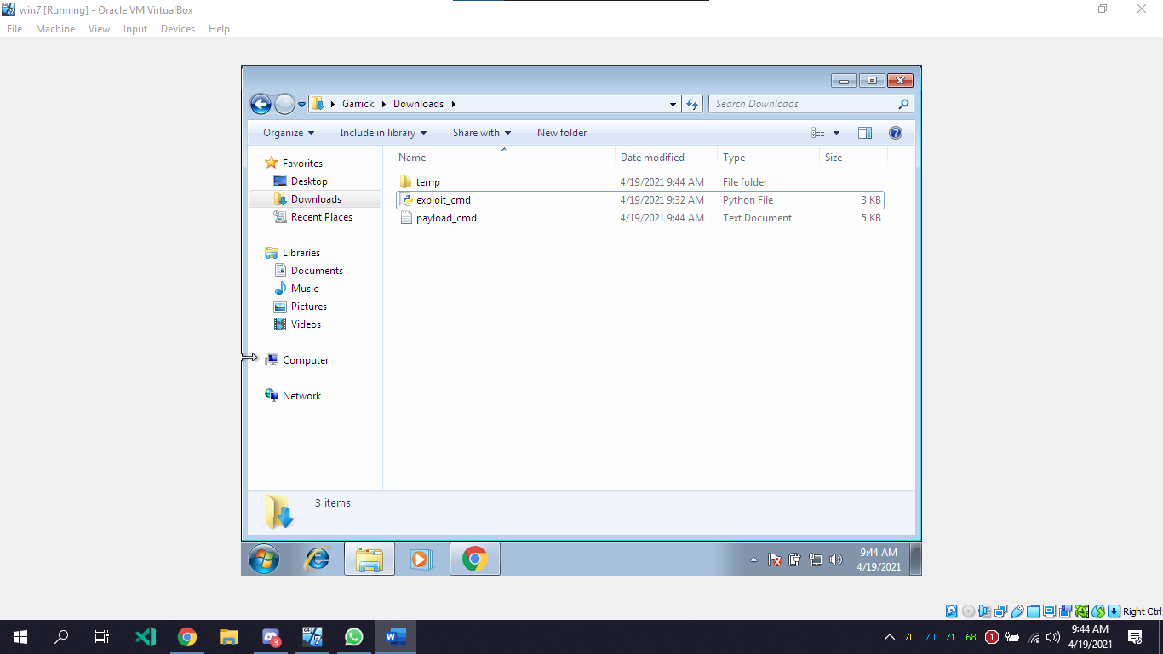

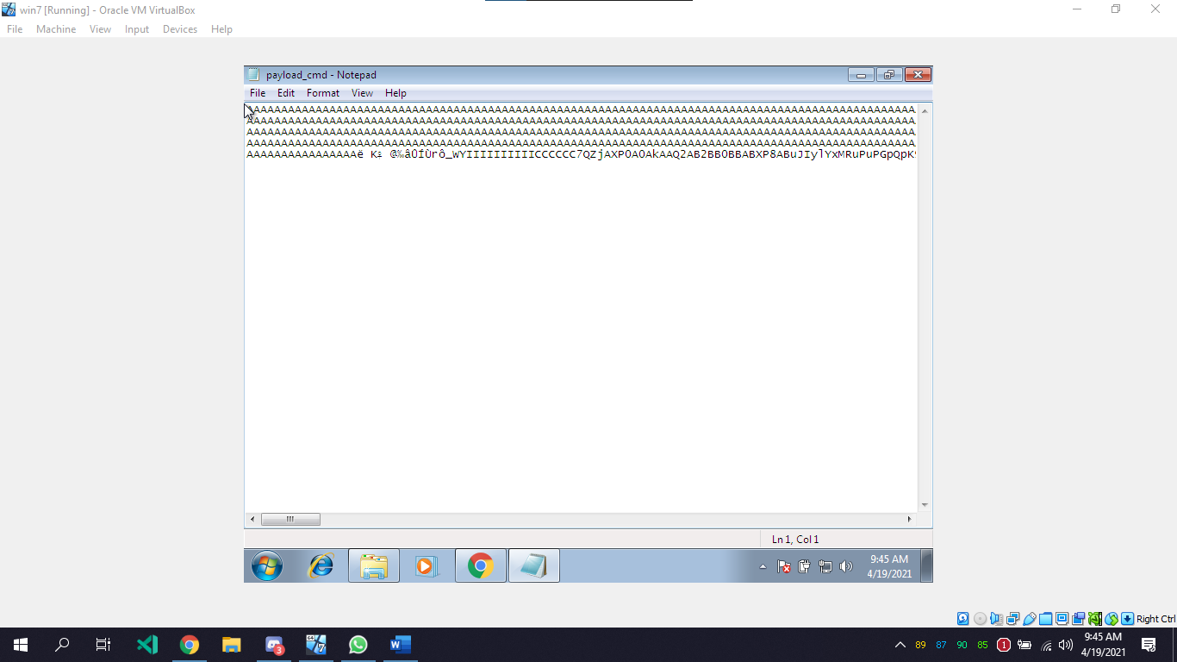

Copy the payload and open the frigate software with admin privileges, Go to disks and select find computer and paste the payload in it.

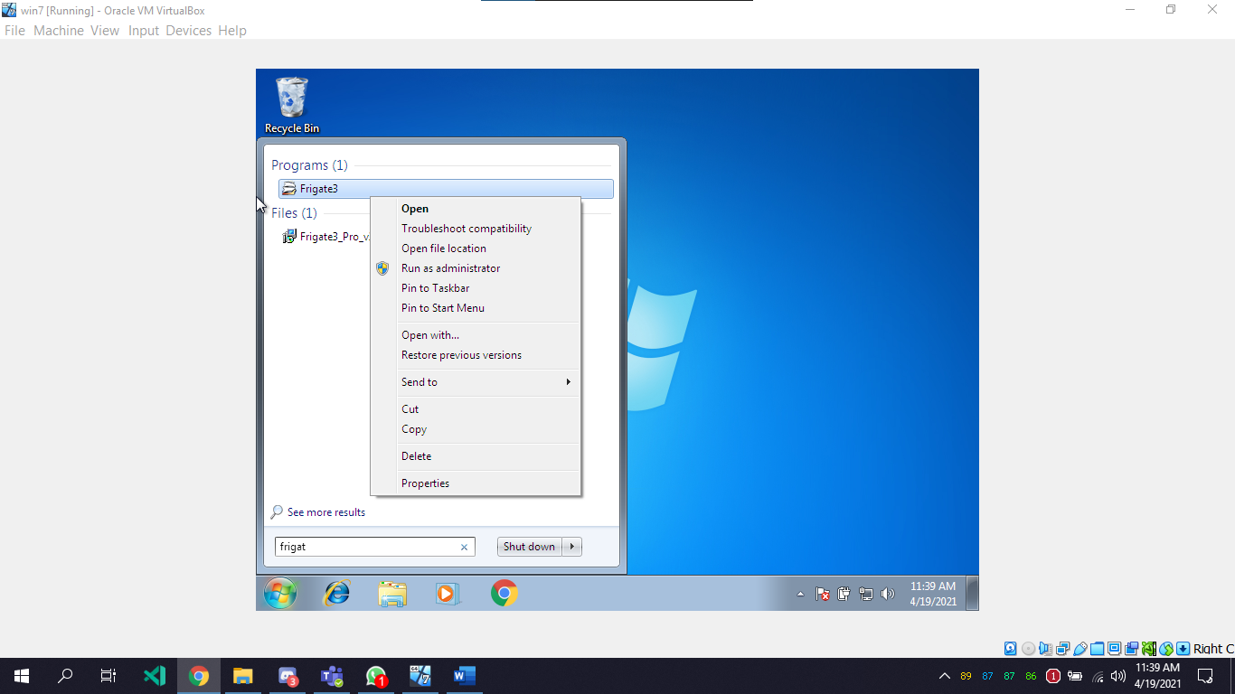

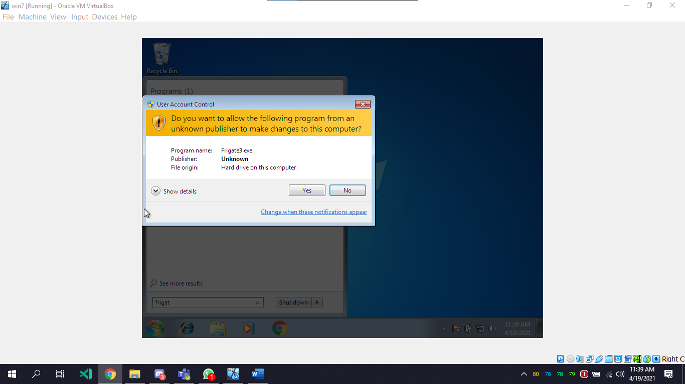

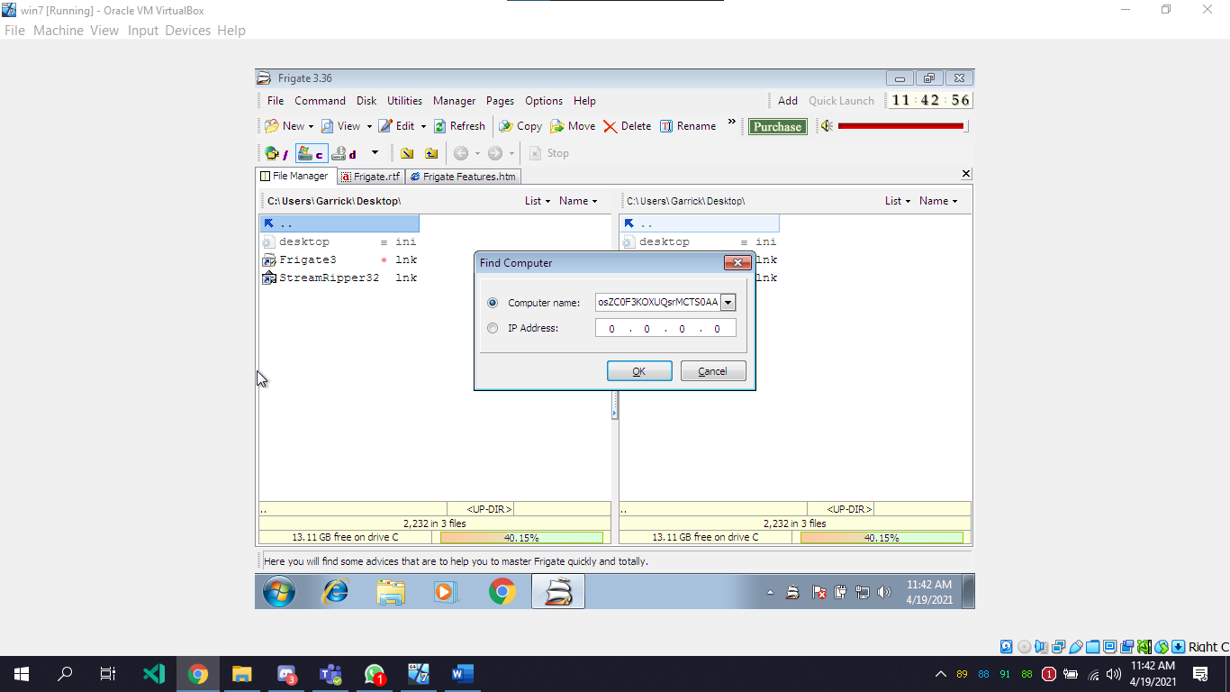

The CMD that opens after crashing the application opens with elevated privileges

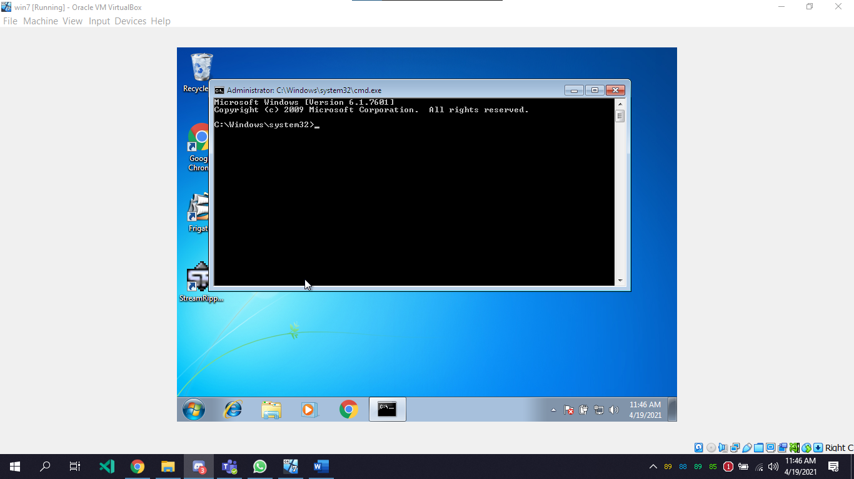

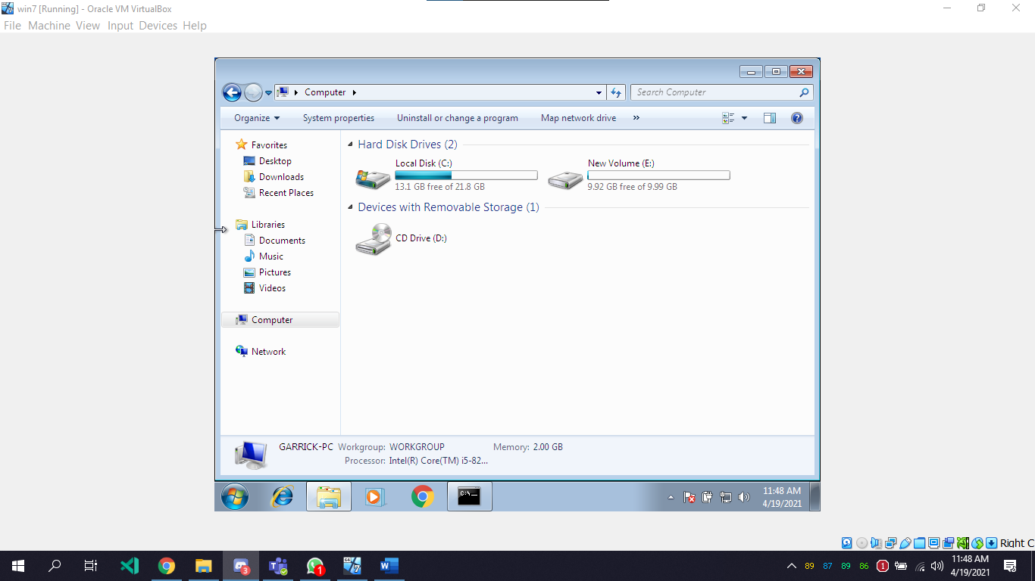

Type diskpart and follow the screenshots

